abhishek

Python Language Fundamentals

Introduction
- Python is a high-level, interpreted, and easy-to-learn programming language created by Guido van Rossum in 1991.
- It is widely used in web development, automation, data science, artificial intelligence, and software testing.
- Python focuses on simple and readable syntax, which makes programming easier for beginners.

1.1 Introduction to Scripting

What is Scripting?
- Scripting means writing small programs to automate repetitive tasks like file handling and data processing.
- Scripts are executed line by line and are easy to write and modify.

Example of a simple script:
print("Welcome to Python")
print("This is a simple script")

Difference between Scripting and Programming
Scripting | Programming
Used for automation and small tasks | Used for building full applications
Interpreted and runs line by line | Usually compiled first
Faster to write | Takes more time to design
Example: Python, JavaScript | Example: C, C++, Java

1.2 History and Features of Python

Evolution of Python
- 1989: Python started by Guido van Rossum
- 1991: First public release
- 2000: Python 2.0 introduced
- 2008: Python 3.0 launched
- 2020: Python 2 stopped, Python 3 is now standard

Unique Features of Python

Feature | Explanation
Simple syntax | Easy to read and write
Interpreted | No need to compile
Platform independent | Works on Windows, Linux, Mac
Dynamically typed | No need to declare data type
Large library | Many ready-made functions

1.3 Python Pre-requisites

Required Software and Hardware
- Computer with minimum 4 GB RAM
- Windows / Linux / macOS
- Python installed
- Any IDE like VS Code, PyCharm, IDLE

Basic Programming Knowledge
Basic understanding of:
- What is a program
- What is logic
- How to solve simple problems

1.4 Environment Setup for Python

Installing Python
Steps:
- Download Python from python.org
- Install it
- Tick ✅ Add Python to PATH
- Check version using:
python --version

Setting up IDE
Common IDEs:
IDE | Use
VS Code | Best for general use
PyCharm | For big projects
IDLE | For beginners
Jupyter | For data science

1.5 Python Basic Datatypes

Main Data Types

Data Type | Meaning | Example
int | Whole numbers | 10, -5
float | Decimal numbers | 3.14, 2.5
str | Text | "Python"
bool | True / False | True

Example Program:

age = 20 # int
price = 99.5 # float
name = "Ram" # string
is_student = True # boolean

print(age, price, name, is_student)

Type Conversion (Type Casting)

- Type conversion means changing one data type into another using functions like int(), float(), and str().
- It is useful when handling user input and calculations.

Example:

x = "10"
y = int(x) # converts string to int
z = float(y) # converts int to float
print(y, z)

1.6 Python Variables, Keywords, Comments

Variables
- Variables are used to store data values in memory and can be changed during program execution.
- Python does not require declaring the data type of a variable.
Example:

name = "Amit"
age = 21

Keywords
- Keywords are reserved words in Python that have special meaning, such as if, else, for, while, True, False, break and continue.
- These words cannot be used as variable names.

Comments
- Comments are used to explain the code and are ignored by the Python interpreter.
- In Python, comments start with the # symbol.

Example:
# This is a comment
print("Hello")

1.7 Python Operators and Casting

Python Operators
- Python provides arithmetic, comparison, logical, and bitwise operators to perform different operations.
- These operators are used in calculations, conditions, and logical decisions.

Type | Example
Arithmetic | +, -, *, /
Comparison | ==, >, <
Logical | and, or, not
Bitwise | &

Example:
a = 10
b = 3

print(a + b) # Addition
print(a > b) # Comparison
print(a > 5 and b < 5) # Logical

Type Casting
- Type casting means converting one data type into another, such as converting int to float or string to int.
- It is done using built-in functions like int(), float(), and str().
Example:

x = 5
y = float(x)
print(y)

pavithra

1. Python I/O Expressions

Definition
Python I/O (Input/Output) expressions are used to receive data from the user and display results on the screen.

Diagram
User ⇄ Python Program ⇄ Screen

2. Input Statement – input()

Definition
input() is a built-in function used to read data entered by the user from the keyboard.

Diagram
Keyboard → input() → Variable

3. Reading Inputs of Different Data Types

Definition
The data received by input() is always a string, so it must be converted into other data types like int or float when needed.

Diagram
"25" → int() → 25
"3.5" → float() → 3.5

4. Formatting the Output – print()

Definition
print() is used to display text, values, and results on the screen.

Diagram
Data → print() → Screen Output

5. String Formatting Methods

Definition
String formatting is used to combine text and variable values in a neat and readable way.
Example:
name = "Tom"
print(f"My name is {name}")

Diagram
Text + Variable → Formatted String → Output

6. Python Control Statements

Definition
Control statements control the order of execution of a program.

Diagram
Program Execution → Controlled by Statements

7. Conditional Statements (if, elif, else)

Definition
Conditional statements are used to make decisions based on conditions.

Diagram
Condition → True Block / False Block

8. Nested Conditional Statements

Definition
A nested conditional statement is an if statement inside another if statement.

Diagram
if
└── if
└── Statement

9. Loop Control Statements (for, while)

Definition
Loops are used to repeat a block of code multiple times.

Diagram
Repeat → Repeat → Repeat → Stop

10. break, continue, pass

Definitions
Statemet | Meaning
break | Stops the loop completely
continue | Skips the current step
pass | Does nothing (placeholder)

Diagram
Loop
├── break → Exit loop
├── continue → Skip step
└── pass → No action

yamini
3.Python Control Statements

Introduction
Python control statements are fundamental building blocks used to control the flow of execution in a program. They help in making decisions, repeating tasks, and managing program logic efficiently. In this presentation, we will understand Python conditional statements such as if, elif, and else, along with loop statements like for and while. We will also explore loop control statements including break, continue, and pass with examples and flowcharts for better understanding.

Explanation
Python control statements control the execution flow of a program.
They decide which block runs, how many times it runs, and when it stops.

Types
- Conditional control statements
- Loop control statements
Flowchart
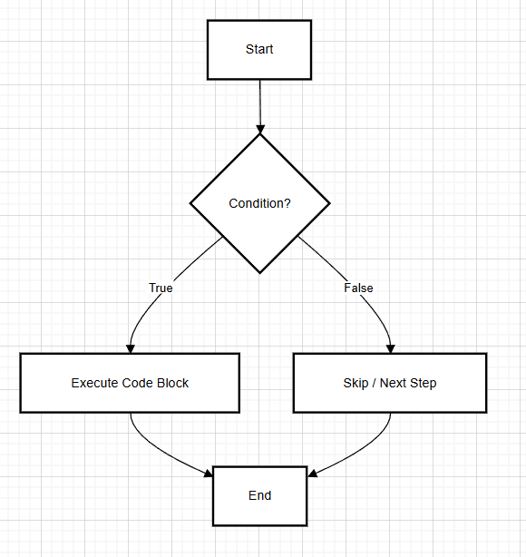
Python Conditional Control Statements

Explanation
Conditional statements are used to make decisions based on conditions.
If the condition is True, a block executes; otherwise, another block run
🔹 if, elif, else Statements

Explanation
- if checks the first condition
- elif checks another condition
- else runs if all conditions fail
Only one block executes.

Code Example
marks = 75

if marks >= 90:
print("Grade A")
elif marks >= 60:
print("Grade B")
else:
print("Grade C")

Output:
Grade B

FLOWCHART
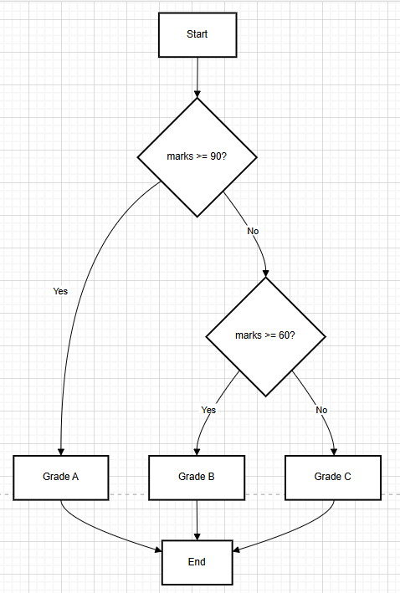

🔹 Nested Conditional Statements

Explanation
Nested conditionals mean if inside another if.
Used when decisions depend on multiple levels of conditions.

Code Example
age = 20
has_id = True

if age >= 18:
if has_id:
print("Allowed to enter")
else:
print("ID required")
else:
print("Not allowed")

Output:
Allowed to enter

Flowchart
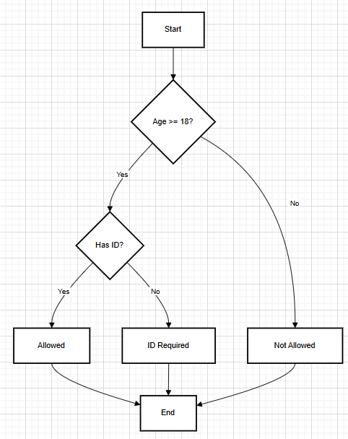

🔹 Python Loop Control Statements

Explanation
Loops are used to repeat code multiple times.
Python supports for and while loops.

🔹 for Loop

Explanation
A for loop iterates over a sequence like list, range, or string.

Code Example
for i in range(1, 6):
print(i)

Output
1
2
3
4
5

Flowchart
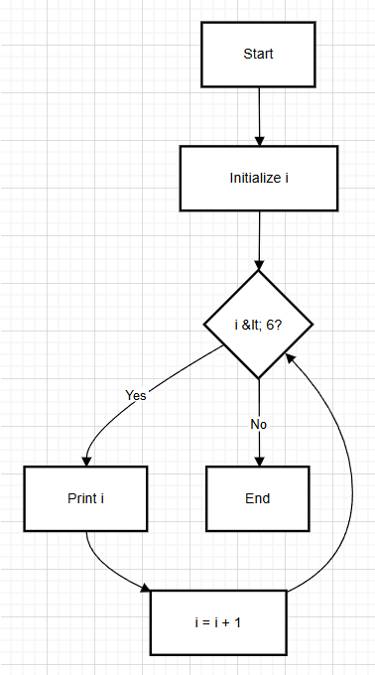

🔹 while Loop

Explanation
A while loop runs as long as a condition is True.

Code Example
count = 1
while count <= 5:
print(count)
count += 1
Output
1
2
3
4
5
Flowchart
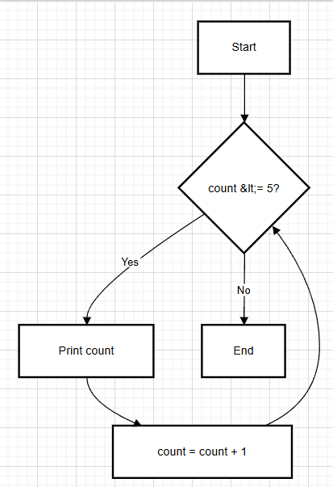

🔹 break, continue, pass Statements

break

Explanation
break terminates the loop immediately.

Code:
for i in range(5):
if i == 3:
break
print(i)

Output
0
1
2
continue

Explanation
continue skips the current iteration.

Code
for i in range(5):
if i == 2:
continue
print(i)

Output
0
1
3
4

pass

Explanation
pass does nothing and is used as a placeholder.

Code
for i in range(3):
Pass

Output:
(No output)

FLOWCHART
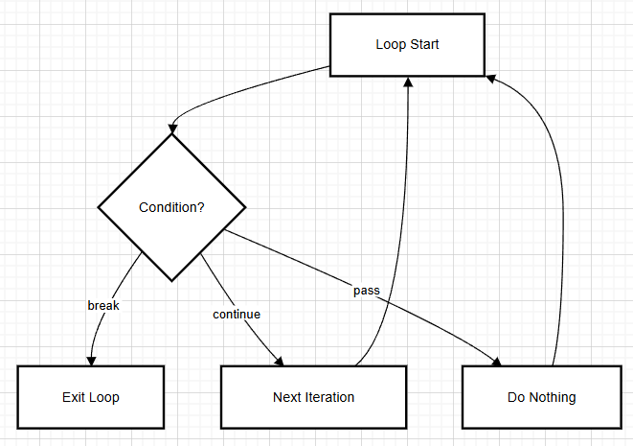
Conclusion:
In conclusion, Python control statements play a crucial role in writing logical and efficient programs. Conditional statements help in decision-making, while loops allow repeated execution of code based on conditions. Loop control statements like break, continue, and pass provide better control over loop execution. Understanding these concepts helps in developing structured, readable, and optimized Python programs.

lokesh

Data Structures in Python

Introduction
In Python, data structures are used to store, organize, and manage data efficiently.
They allow us to store multiple values under a single variable name and perform operations like accessing, updating, adding, deleting, and iterating over data.
The main built-in data structures in Python are:
- List
- Tuple
- Dictionary
- Set
Each data structure has its own purpose and behavior.

1. List

What is a List?
A list is an ordered and mutable collection of elements.
This means:
- Elements are stored in a specific order
- Values can be changed after creation
- Duplicate values are allowed
- Different data types can be stored together

Example
numbers = [10, 20, 30, 40]

Accessing Elements in a List
List elements are accessed using index values, starting from 0.
numbers = [10, 20, 30, 40]
print(numbers[0]) # 10
print(numbers[-1]) # 40

Updating Elements in a List
Lists are mutable, so elements can be updated.
numbers = [10, 20, 30]
numbers[1] = 25
print(numbers) # [10, 25, 30]

Slicing a List
Slicing is used to access a portion of a list.
numbers = [10, 20, 30, 40, 50]
print(numbers[1:4]) # [20, 30, 40]

Adding Elements to a List
Elements can be added in different ways.
numbers = [10, 20]
numbers.append(30)
numbers.insert(1, 15)
print(numbers) # [10, 15, 20, 30]

Deleting Elements from a List
Elements can be removed by value or position.
numbers = [10, 20, 30]
numbers.remove(20)
numbers.pop()
print(numbers) # [10]

2. Tuple

What is a Tuple?
A tuple is an ordered but immutable collection of elements.
Once created, its values cannot be changed.

Example
coordinates = (10, 20, 30)

Accessing Elements in a Tuple
coordinates = (10, 20, 30)
print(coordinates[1]) # 20

Slicing a Tuple
coordinates = (10, 20, 30, 40)
print(coordinates[1:3]) # (20, 30)

Updating Tuple Elements
Tuples do not support updating.
coordinates[0] = 50 # Error: tuple is immutable

When to Use Tuples
- When data should not change
- When data integrity is important
- For fixed configuration values

3. Dictionary

What is a Dictionary?
A dictionary stores data in key–value pairs, where each key maps to a value.

Example
student = {
"name": "Lokesh",
"age": 21,
"course": "Python"
}

Accessing Dictionary Values
Values are accessed using keys.
print(student["name"]) # Lokesh

Updating Dictionary Values
student["age"] = 22
print(student["age"]) # 22

Adding New Key–Value Pairs
student["grade"] = "A"

Deleting Elements from Dictionary
del student["course"]

Iterating Over a Dictionary
for key, value in student.items():
print(key, value)

When to Use Dictionaries
- When data needs a label
- When fast lookup is required
- When storing structured information

4. Set

What is a Set?
A set is an unordered collection of unique elements.
Duplicate values are automatically removed.

Example
marks = {80, 85, 90, 85}
print(marks) # {80, 85, 90}

Adding Elements to a Set
marks.add(95)

Removing Elements from a Set
marks.remove(80)

Accessing Set Elements
Sets do not support indexing.
Elements are accessed using loops.
for mark in marks:
print(mark)

When to Use Sets
- When duplicate values must be avoided
- When performing membership checks
- For unique collections

5. Working with For Loops on Data Structures

Purpose of For Loop
A for loop is used to iterate over elements of a data structure one by one.

For Loop with List
numbers = [1, 2, 3]
for num in numbers:
print(num)

For Loop with Tuple
colors = ("red", "blue", "green")
for color in colors:
print(color)

For Loop with Dictionary
student = {"name": "Lokesh", "age": 21}
for key in student:
print(key, student[key])

For Loop with Set
values = {10, 20, 30}
for val in values:
print(val)

6. Usage of in Keyword

What is the in Keyword?
The in keyword is used to check whether an element exists in a data structure.

in with List
numbers = [10, 20, 30]
print(20 in numbers) # True
print(50 in numbers) # False

in with Tuple
colors = ("red", "blue")
print("red" in colors) # True

in with Dictionary
Checks only keys, not values.
student = {"name": "Lokesh", "age": 21}
print("name" in student) # True
print(21 in student) # False

in with Set
marks = {80, 90, 100}
print(90 in marks) # True

Conclusion
Python data structures such as List, Tuple, Dictionary, and Set provide powerful ways to store and manage data.
Understanding how to access, update, slice, add, delete, iterate, and check membership forms a strong foundation for Python programming and real-world applications.

ritikesh
5.Python Strings

Definition of Python Strings
Strings are immutable sequences of characters enclosed in single (' '), double (" "), or triple (''' ''') quotes. They're Python's core text data type, supporting indexing, slicing, and built-in methods.

5.1 Slicing and Formatting Strings

Slicing Strings
Slicing allows you to extract a specific portion (substring) of a string using the syntax string[start:stop:step].
- Start: The beginning index (inclusive).
- Stop: The ending index (exclusive).
- Step: The interval between characters (optional).
Python
text = "Python"
print(text[0:2]) # Output: 'Py' (Indices 0 and 1)
print(text[2:]) # Output: 'thon' (From index 2 to the end)
print(text[::-1]) # Output: 'nohtyP' (Reverses the string)

Formatting Strings
Modern Python provides two primary ways to inject variables into strings:
- f-strings (Recommended): Prefixed with f, these allow you to embed expressions directly inside curly braces {}. They are faster and more readable.
  - Example: f"Hello, {name}!"
- format() method: Uses placeholders {} and passes values as arguments.
  - Example: "User: {}".format(username)

5.2 Built-in Methods
Python includes a variety of built-in methods to transform and analyze strings. Because strings are immutable, these methods always return a new string rather than modifying the original.

Common Methods
Method | Description | Example
lower() | Converts all characters to lowercase. | "Hi".lower() →"hi"
upper() | Converts all characters to uppercase. | "hi".upper() →"HI"
split(sep) | Breaks a string into a list based on a separator. | "a,b,c".split(",") → ['a', 'b', 'c']
join(list) | Concatenates a list into a single string. | "-".join(['a', 'b']) →"a-b"
strip() | Removes whitespace from both ends. | " hi ".strip() →"hi"
replace() | Replaces a substring with another. | "apple".replace("a", "o") →"opple"

Conclusion
Python strings provide powerful slicing, f-string formatting, and methods like split(), join(), strip(), and replace() for effective text processing in software testing and development projects.

sudha

6.Python Functions
Python functions help us organize code, avoid repetition, and improve, readability. The given data mainly focuses on built-in functions, range(), and user-defined functions.

1️. Built-in Functions and range() Function

🔹 Built-in Functions
Built-in functions are already available in Python, so we can use them directly without writing extra code.
Common built-in functions:
- len() → Finds length of a string, list, tuple, etc.
- type() → Finds the data type of a variable
- str() → Converts data into string
- int() → Converts data into integer

🔹 range() Function
The range() function is used to generate a sequence of numbers.
Syntax : range(start, stop, step)

Example: for i in range(1, 6):
print(i)

Commonly used in:
- Loops
- Counters
- Iterations

2️. User-Defined Functions
User-defined functions are created by programmers to perform a specific task.

🔹 Creating Functions
Functions are created using the def keyword.
Syntax:
def function_name(parameters):
statements
return value
Example:
def add(a, b):
return a + b

result = add(10, 20)
print(result)

🔹 Parameters and Return Values
- Parameters: Values passed to a function.
- Return value: Output given back by the function using return.

Benefits:
- Code reusability
- Easy debugging
- Better structure

Flowchart:
Python Function Working Process

│ START |
|
▼
│ Is Function Built-in│
| |
▼ ▼
│Yes | │No |
| |
▼ ▼
│ Use len(), │ │ Create Function │
│ type(), range() ││ using def │
│ │
▼ ▼
│ Get Output │ │ Pass Parameters │
│
▼
│ Display Result │
|
▼
| END |

